## QUESTION 1

-- Question 1  
  
(1)  
  
SELECT STUDENT.SNAME, COURSE.CNAME  
FROM STUDENT, MARK, COURSE  
WHERE STUDENT.SID=MARK.SID AND COURSE.CID=MARK.CID  
AND MAKR.SCORE>85;

(2)

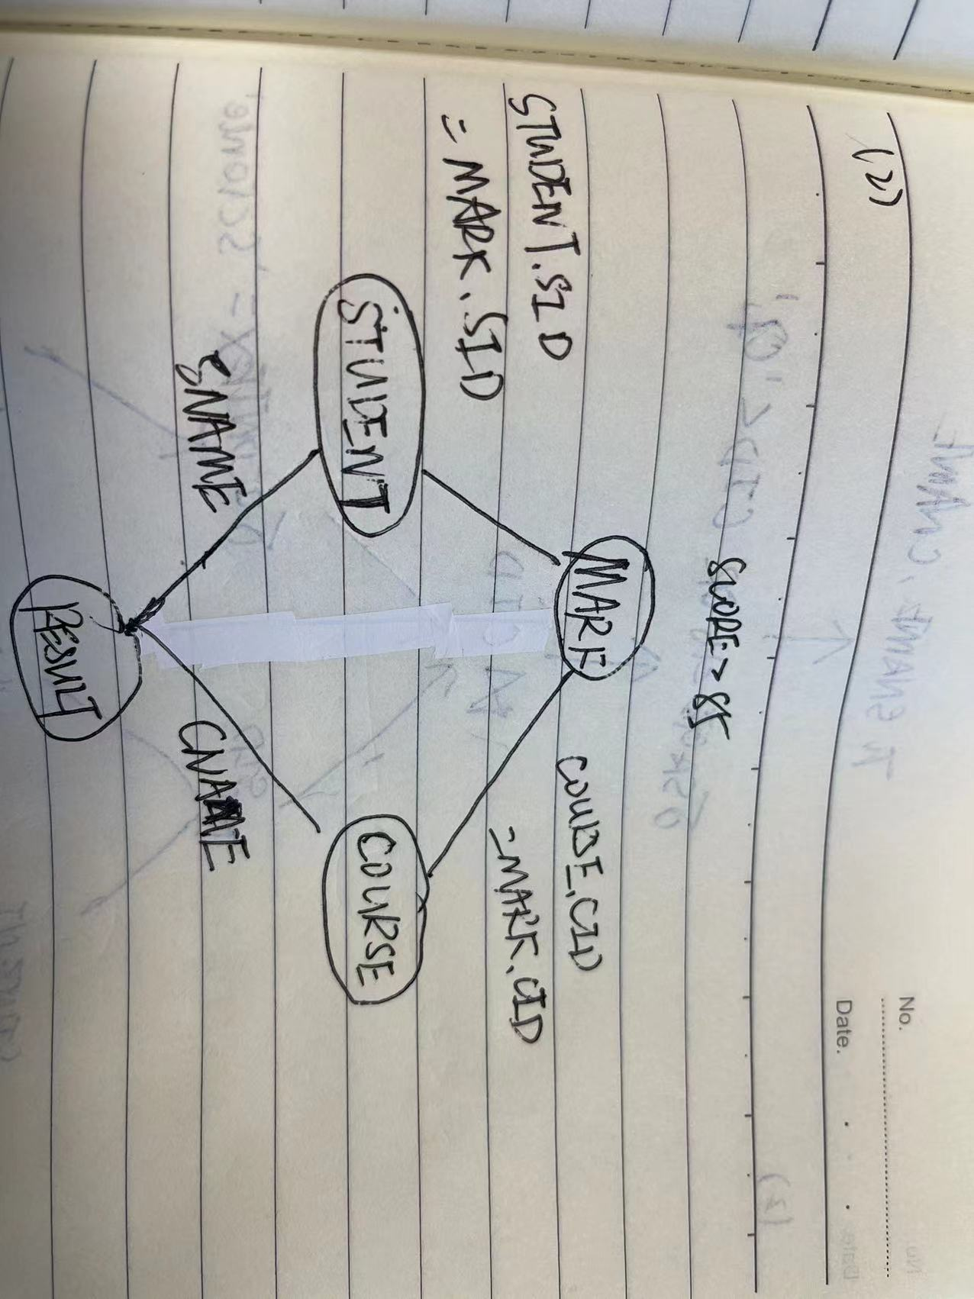

(3)

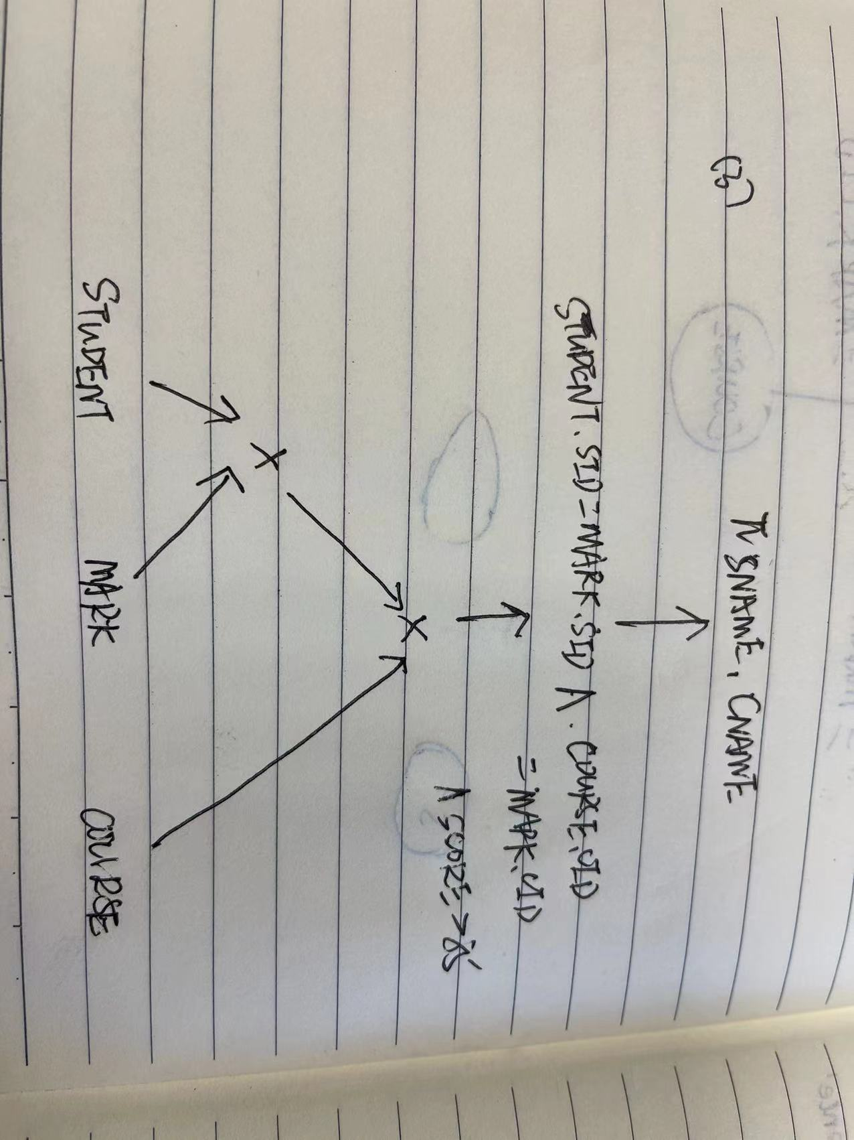

## QUESTION 2

(1)  
SELECT SNAME, CNAME  
FROM STUDENT JOIN MARK ON STUDENT.SID=MARK.SID  
JOIN COURSE ON COURSE.CID=MARK.CID  
WHERE (SAGE<16 OR MARK.CID<'C2')  
AND CCONTEXT='Science';

(2)

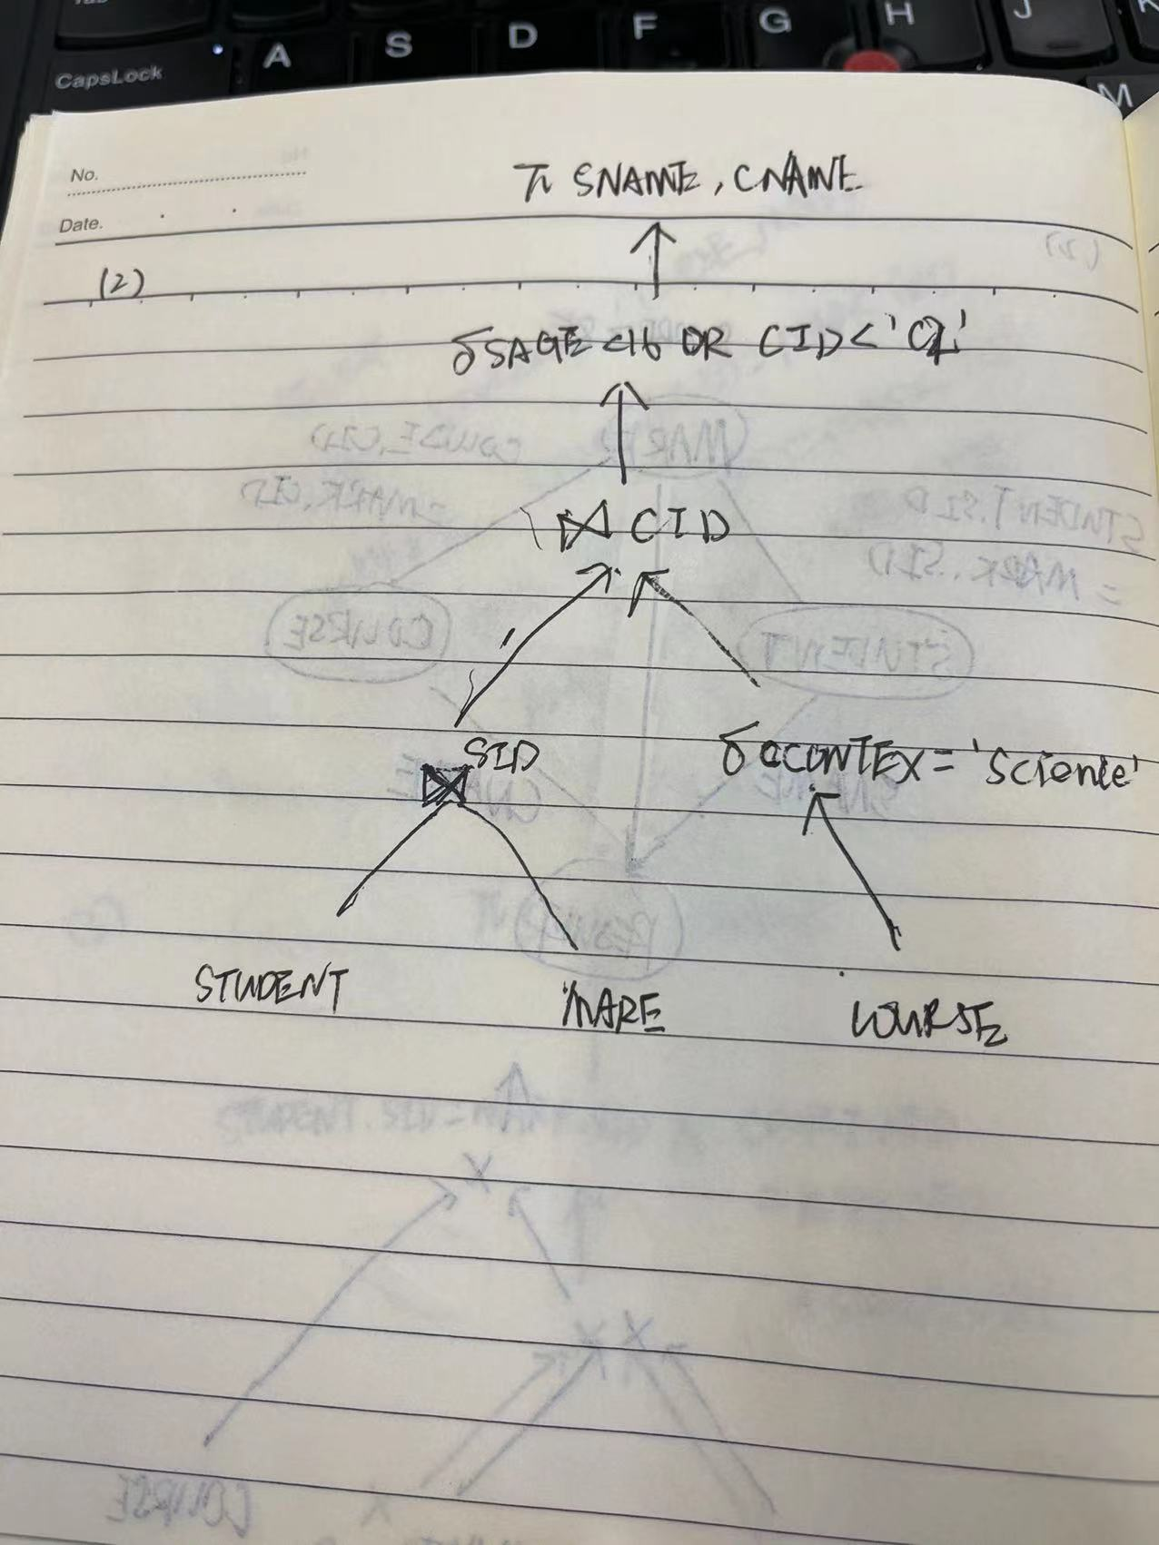

## QUESTION 3

For postgraduate students, the query is (5 marks):

SELECT CNAME FROM STUDENT, COURSE, MARK

WHERE STUDENT.SID = MARK.SID

AND COURSE.CID = MARK.CID

AND SNAME = "James" AND SCORE > 85

STEP1:

Replace STUDENT by (STUDENT1 U STUDENT2 U STUDENT3)

And replace MARK by 𝑀𝐴𝑅𝐾⋉𝑆𝐼𝐷(𝑆𝑇𝑈𝐷𝐸𝑁𝑇2) U 𝑀𝐴𝑅𝐾⋉𝑆𝐼𝐷(𝑆𝑇𝑈𝐷𝐸𝑁𝑇1) U 𝑀𝐴𝑅𝐾⋉𝑆𝐼𝐷(𝑆𝑇𝑈𝐷𝐸𝑁𝑇3)

For relation COURSE, just need CID and CNAME, so just use COURSE1.

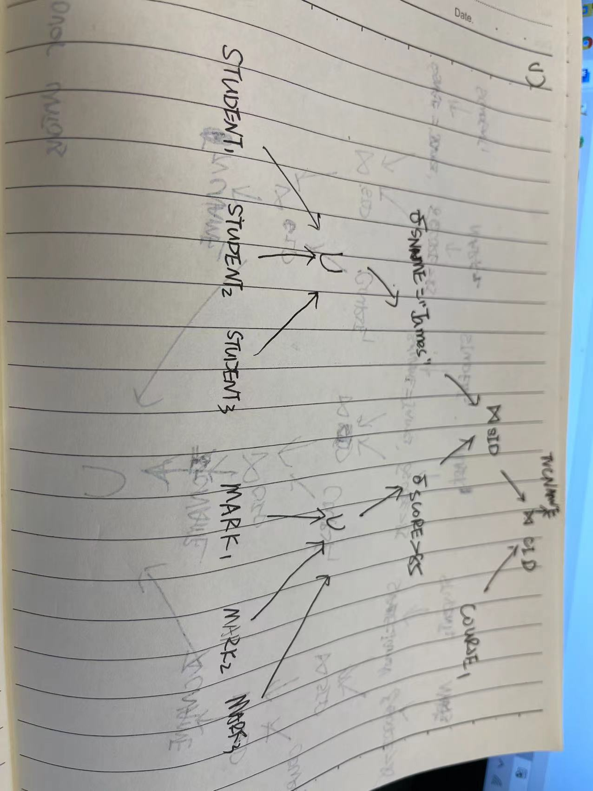

STEP2:

Selection first:

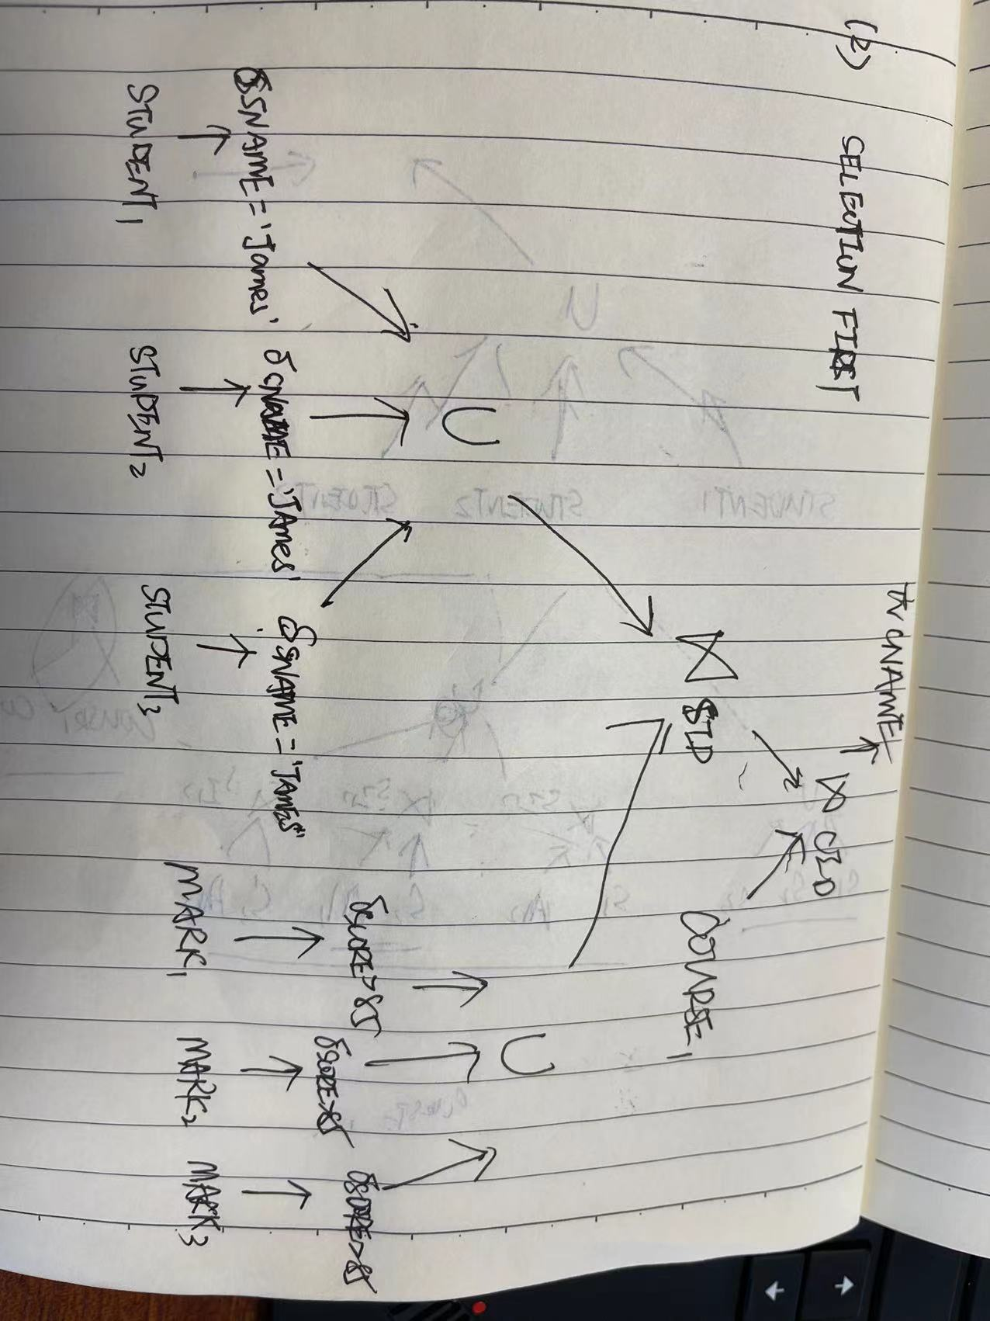

STEP3:

Joins over unions and elimination of the empty intermediate relations

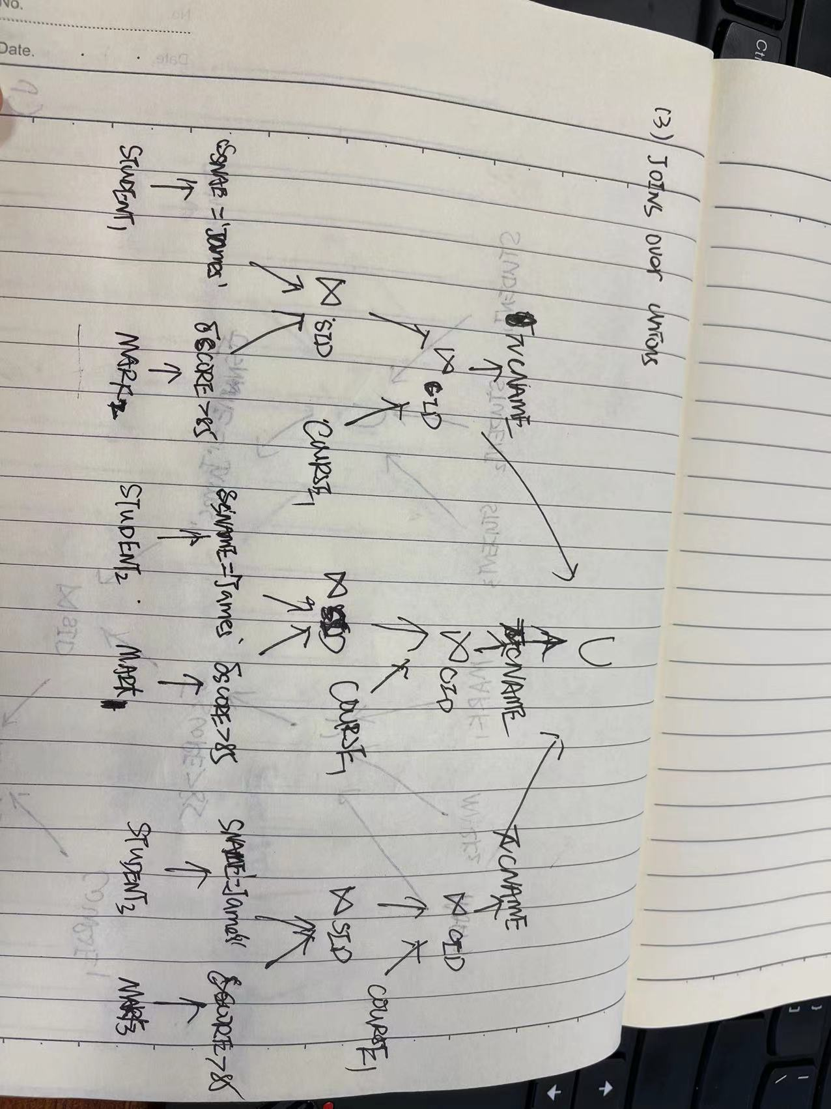

## QUESTION 4

使用SQAllocation 算法要执行四次迭代，第一次迭代选择灵活度最小的q4, 把它分配到s1, 因此s1的负载更新为2。第二次迭代可以选择的查询是q2或者q3, 假定选择q2并把它分配到s2, 此时s2的负载增加到3。第三次迭代选择的查询时q3, 分配到s1，此时s1的负载增加到3。最后，第四次迭代把q1分配到具有最小负载的s3或者s4.

Using the SQAllocation algorithm to perform four iterations, the first iteration selects the least flexible q4 and assigns it to s1, so the load of s1 is updated to 2. The query that can be selected for the second iteration is q2 or q3. Assuming that q2 is selected and assigned to s2, the load of s2 increases to 3. The query selected in the third iteration is q3, which is allocated to s1, and the load of s1 increases to 3. Finally, the fourth iteration assigns q1 to s3 or s4 with the smallest load.

Second solution:

As the first solution, the first iteration selects the least flexible q4 and assigns it to s1, the load of s1 is updated to 2. Then select q3 and assigned to s3 and the load of s3 is updated to 3.

Then select q2 and assigned to s2, the load of s2 increases to 3, And the last iteration assigns q1 to s1, the load of s1 will increase to 3.